50sites

Yanlin Ma + Kevin Murgas

April 13, 2020

Model 3:

$$y_{i,j,k}=μ+b_{j}+I_{tumor}*(β_{T}+c_{j}+d_{k})+ϵ_{i}$$

$$b_{j}∼N(0,σ_{P}), c_{j}∼N(0,σ_{PT}), d_{k}∼N(0,σ_{T}), ϵ_{i}∼N(0,σ_{E})$$

Stan Chain parameters: warmup=200, iter=1000, chains=4, thin=1 (no thin), adapt_delta=0.999, seed=123

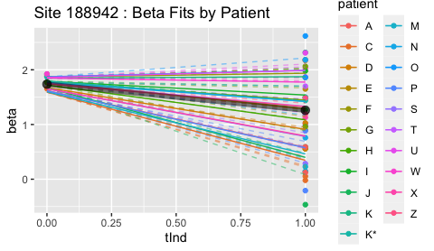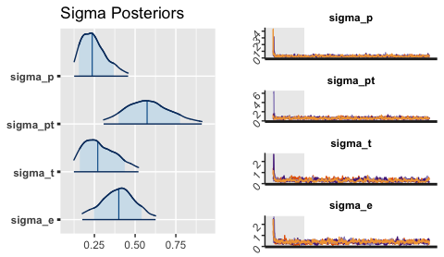  
Site 188942: Parameter posterior summary

|  |  |  |  |  |
| --- | --- | --- | --- | --- |
|  | mean | 50% | n_eff | Rhat |
| mu | 1.7372137 | 1.7450223 | 1519.5787 | 1.003040 |
| betaT | -0.4763895 | -0.4767033 | 1424.3679 | 1.000978 |
| sigma_p | 0.2504852 | 0.2364350 | 573.0162 | 1.005484 |
| sigma_pt | 0.5828076 | 0.5737348 | 868.7332 | 1.002579 |
| sigma_t | 0.2870038 | 0.2705944 | 163.4863 | 1.043028 |
| sigma_e | 0.3971746 | 0.3997161 | 182.5023 | 1.047413 |

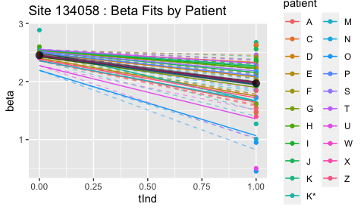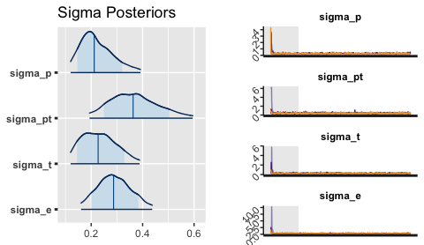  
Site 134058: Parameter posterior summary

|  |  |  |  |  |
| --- | --- | --- | --- | --- |
|  | mean | 50% | n_eff | Rhat |
| mu | 2.4514172 | 2.4570229 | 2011.6849 | 1.001014 |
| betaT | -0.4843118 | -0.4889725 | 1690.3878 | 1.000339 |
| sigma_p | 0.2245946 | 0.2116925 | 829.2513 | 1.001503 |
| sigma_pt | 0.3696461 | 0.3629561 | 1139.4351 | 1.000380 |
| sigma_t | 0.2333398 | 0.2270752 | 318.9474 | 1.004856 |
| sigma_e | 0.2905685 | 0.2870300 | 458.0135 | 1.002714 |

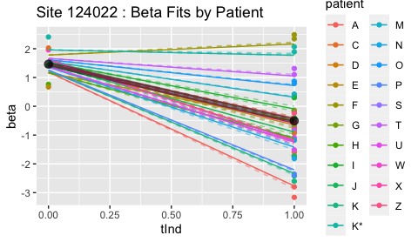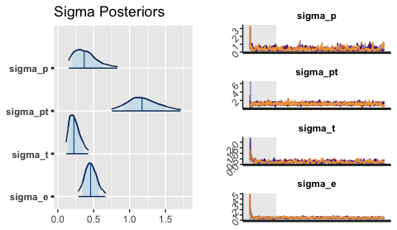  
Site 124022: Parameter posterior summary

|  |  |  |  |  |
| --- | --- | --- | --- | --- |
|  | mean | 50% | n_eff | Rhat |
| mu | 1.4647804 | 1.4708571 | 1929.1565 | 0.9995529 |
| betaT | -1.9704080 | -1.9813843 | 709.4317 | 1.0031398 |
| sigma_p | 0.3968000 | 0.3680613 | 310.0443 | 1.0094823 |
| sigma_pt | 1.1895216 | 1.1730184 | 1144.3884 | 1.0029965 |
| sigma_t | 0.2371801 | 0.2248738 | 229.2865 | 1.0136931 |
| sigma_e | 0.4616952 | 0.4567374 | 672.0426 | 1.0040794 |

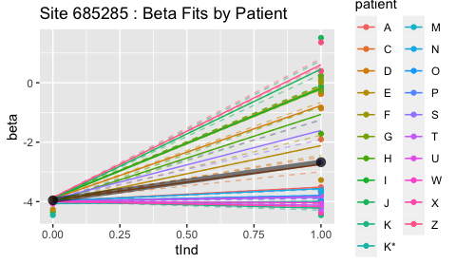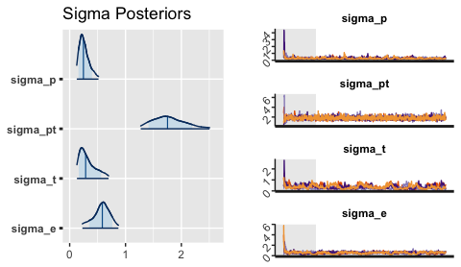  
Site 685285: Parameter posterior summary

|  |  |  |  |  |
| --- | --- | --- | --- | --- |
|  | mean | 50% | n_eff | Rhat |
| mu | -3.9563610 | -3.9768471 | 848.8535 | 1.005064 |
| betaT | 1.2824048 | 1.3143106 | 502.2575 | 1.008941 |
| sigma_p | 0.2670080 | 0.2462787 | 340.8080 | 1.021890 |
| sigma_pt | 1.7842031 | 1.7519757 | 1877.4955 | 1.000076 |
| sigma_t | 0.3274907 | 0.2860263 | 110.6397 | 1.047968 |
| sigma_e | 0.5728860 | 0.5846188 | 172.6394 | 1.027851 |

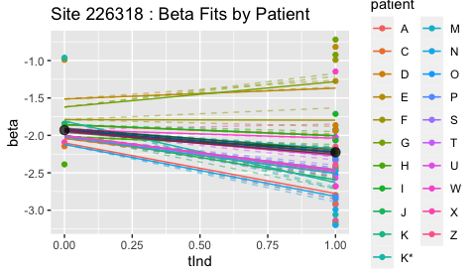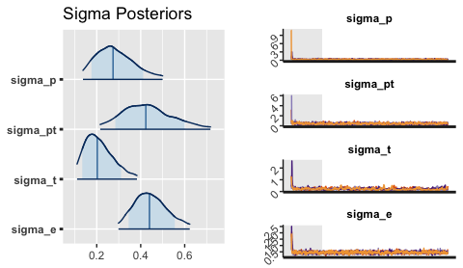  
Site 226318: Parameter posterior summary

|  |  |  |  |  |
| --- | --- | --- | --- | --- |
|  | mean | 50% | n_eff | Rhat |
| mu | -1.9292787 | -1.9391604 | 1708.7688 | 1.001593 |
| betaT | -0.2962560 | -0.2743835 | 1577.4367 | 1.001731 |
| sigma_p | 0.2867203 | 0.2740934 | 574.7208 | 1.006570 |
| sigma_pt | 0.4330370 | 0.4230416 | 808.6721 | 1.001898 |
| sigma_t | 0.2144351 | 0.2026314 | 215.4535 | 1.041297 |
| sigma_e | 0.4461225 | 0.4399058 | 959.8290 | 1.006319 |

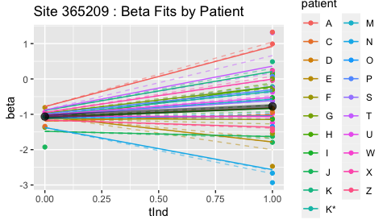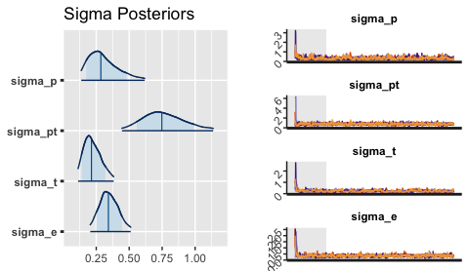  
Site 365209: Parameter posterior summary

|  |  |  |  |  |
| --- | --- | --- | --- | --- |
|  | mean | 50% | n_eff | Rhat |
| mu | -1.0636928 | -1.0752418 | 988.3567 | 1.002143 |
| betaT | 0.2868818 | 0.2630559 | 1208.3648 | 1.001428 |
| sigma_p | 0.3099227 | 0.2852094 | 391.6510 | 1.016905 |
| sigma_pt | 0.7632258 | 0.7474807 | 1234.1154 | 1.003549 |
| sigma_t | 0.2241081 | 0.2138110 | 186.4515 | 1.028458 |
| sigma_e | 0.3464037 | 0.3423545 | 573.3760 | 1.011291 |

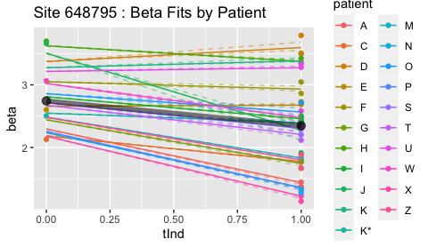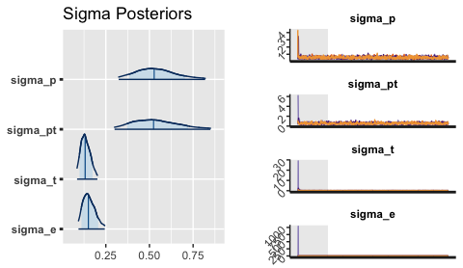  
Site 648795: Parameter posterior summary

|  |  |  |  |  |
| --- | --- | --- | --- | --- |
|  | mean | 50% | n_eff | Rhat |
| mu | 2.7438293 | 2.7456830 | 919.1232 | 1.0020572 |
| betaT | -0.3958807 | -0.3943754 | 1107.2506 | 1.0042783 |
| sigma_p | 0.5385209 | 0.5270050 | 1036.3577 | 0.9998504 |
| sigma_pt | 0.5378196 | 0.5233595 | 932.3337 | 1.0011975 |
| sigma_t | 0.1350312 | 0.1316887 | 578.3790 | 1.0136523 |
| sigma_e | 0.1553217 | 0.1500985 | 521.7553 | 1.0114458 |

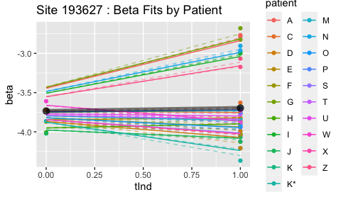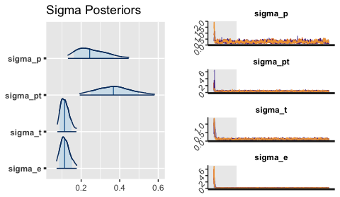  
Site 193627: Parameter posterior summary

|  |  |  |  |  |
| --- | --- | --- | --- | --- |
|  | mean | 50% | n_eff | Rhat |
| mu | -3.7345330 | -3.7406334 | 832.2661 | 0.999337 |
| betaT | 0.0382937 | 0.0300167 | 1033.7189 | 1.000134 |
| sigma_p | 0.2575295 | 0.2444090 | 618.1192 | 1.000834 |
| sigma_pt | 0.3722330 | 0.3674607 | 862.4258 | 1.001352 |
| sigma_t | 0.1165652 | 0.1141236 | 563.7346 | 1.014198 |
| sigma_e | 0.1170470 | 0.1140808 | 604.0207 | 1.008813 |

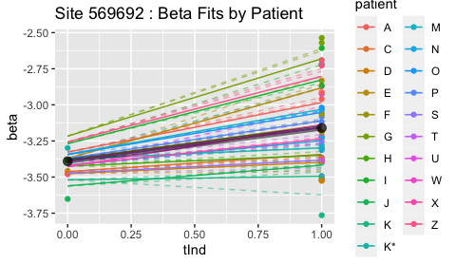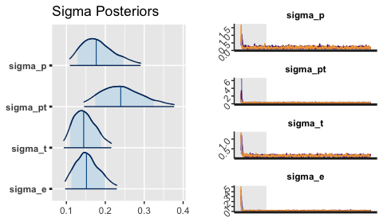  
Site 569692: Parameter posterior summary

|  |  |  |  |  |
| --- | --- | --- | --- | --- |
|  | mean | 50% | n_eff | Rhat |
| mu | -3.3904072 | -3.3929227 | 1851.9624 | 1.005331 |
| betaT | 0.2305616 | 0.2314155 | 1833.4720 | 1.004460 |
| sigma_p | 0.1828165 | 0.1766465 | 1208.6070 | 1.005911 |
| sigma_pt | 0.2452799 | 0.2396631 | 1553.9148 | 1.001704 |
| sigma_t | 0.1473036 | 0.1444680 | 780.3485 | 1.002266 |
| sigma_e | 0.1545776 | 0.1515967 | 536.7203 | 1.005914 |

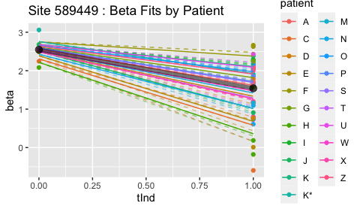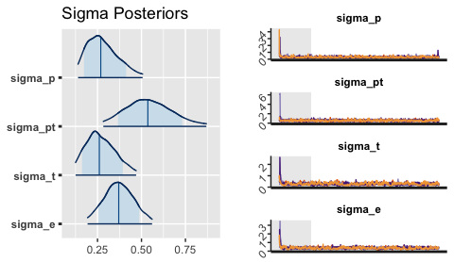  
Site 589449: Parameter posterior summary

|  |  |  |  |  |
| --- | --- | --- | --- | --- |
|  | mean | 50% | n_eff | Rhat |
| mu | 2.5465074 | 2.5481917 | 1079.4691 | 1.004052 |
| betaT | -1.0048844 | -1.0179948 | 932.6178 | 1.003720 |
| sigma_p | 0.2834970 | 0.2685704 | 579.7536 | 1.008936 |
| sigma_pt | 0.5448033 | 0.5363054 | 909.3654 | 1.005031 |
| sigma_t | 0.2719586 | 0.2603686 | 210.6543 | 1.024838 |
| sigma_e | 0.3724509 | 0.3705649 | 370.9468 | 1.012334 |

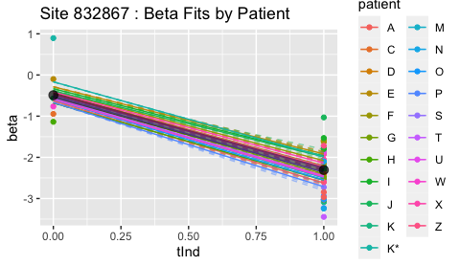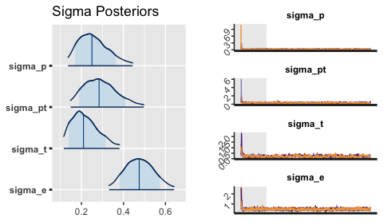  
Site 832867: Parameter posterior summary

|  |  |  |  |  |
| --- | --- | --- | --- | --- |
|  | mean | 50% | n_eff | Rhat |
| mu | -0.4905564 | -0.4855701 | 2875.0759 | 0.9998765 |
| betaT | -1.8162419 | -1.8248687 | 2493.6987 | 1.0006726 |
| sigma_p | 0.2602423 | 0.2498699 | 904.7505 | 1.0031241 |
| sigma_pt | 0.2932329 | 0.2838811 | 868.6874 | 1.0029760 |
| sigma_t | 0.2200204 | 0.2095255 | 205.0221 | 1.0144926 |
| sigma_e | 0.4774200 | 0.4749476 | 1070.0347 | 1.0006800 |

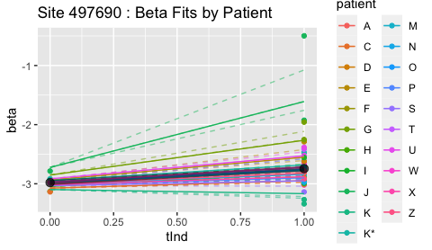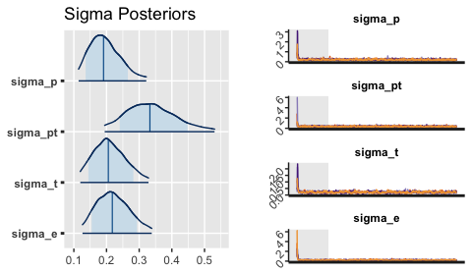  
Site 497690: Parameter posterior summary

|  |  |  |  |  |
| --- | --- | --- | --- | --- |
|  | mean | 50% | n_eff | Rhat |
| mu | -2.9795771 | -2.9791678 | 2194.9448 | 1.000551 |
| betaT | 0.2355062 | 0.2363506 | 1818.0983 | 1.000545 |
| sigma_p | 0.1974795 | 0.1908243 | 887.0191 | 1.004951 |
| sigma_pt | 0.3396979 | 0.3327225 | 1545.2518 | 1.000603 |
| sigma_t | 0.2107526 | 0.2055037 | 400.5068 | 1.004599 |
| sigma_e | 0.2217001 | 0.2177500 | 542.4582 | 1.003057 |

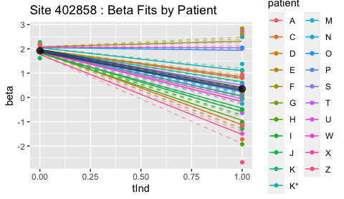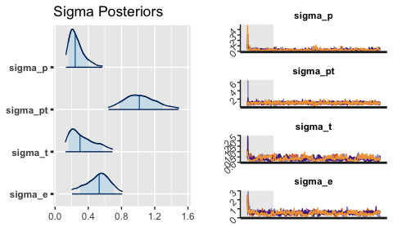  
Site 402858: Parameter posterior summary

|  |  |  |  |  |
| --- | --- | --- | --- | --- |
|  | mean | 50% | n_eff | Rhat |
| mu | 1.9258535 | 1.9347714 | 1325.6476 | 0.9998572 |
| betaT | -1.5746244 | -1.5901743 | 1010.1201 | 1.0028554 |
| sigma_p | 0.2676447 | 0.2420162 | 370.0230 | 1.0008713 |
| sigma_pt | 1.0274421 | 1.0145919 | 1153.9889 | 1.0008596 |
| sigma_t | 0.3371156 | 0.3003036 | 115.2591 | 1.0285650 |
| sigma_e | 0.5181629 | 0.5308069 | 180.9855 | 1.0167747 |

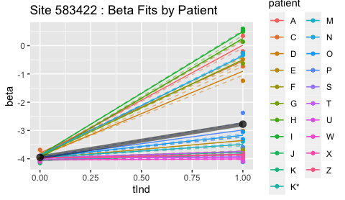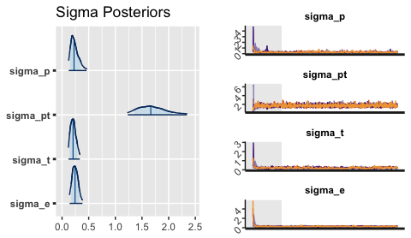  
Site 583422: Parameter posterior summary

|  |  |  |  |  |
| --- | --- | --- | --- | --- |
|  | mean | 50% | n_eff | Rhat |
| mu | -3.9475925 | -3.9530145 | 1647.5813 | 1.000966 |
| betaT | 1.1710350 | 1.1876261 | 428.5156 | 1.009553 |
| sigma_p | 0.2419324 | 0.2249823 | 537.7918 | 1.008551 |
| sigma_pt | 1.6951292 | 1.6649077 | 2239.4551 | 0.999962 |
| sigma_t | 0.2115637 | 0.2069422 | 307.6449 | 1.011708 |
| sigma_e | 0.2471695 | 0.2433213 | 359.2838 | 1.013934 |

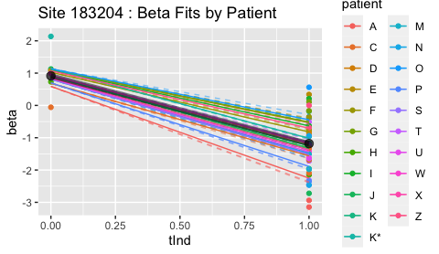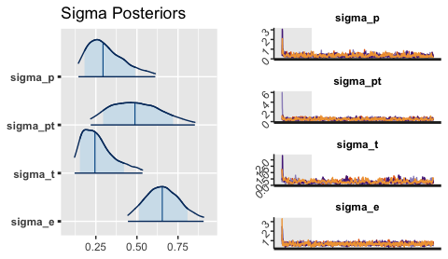  
Site 183204: Parameter posterior summary

|  |  |  |  |  |
| --- | --- | --- | --- | --- |
|  | mean | 50% | n_eff | Rhat |
| mu | 0.9153413 | 0.9203051 | 1838.6063 | 0.9998673 |
| betaT | -2.0971617 | -2.1038923 | 1759.6322 | 0.9999200 |
| sigma_p | 0.3174361 | 0.2936596 | 363.5200 | 1.0060515 |
| sigma_pt | 0.4996009 | 0.4879144 | 572.8201 | 1.0036108 |
| sigma_t | 0.2667643 | 0.2442504 | 191.6842 | 1.0146665 |
| sigma_e | 0.6580574 | 0.6541727 | 843.3459 | 1.0012966 |

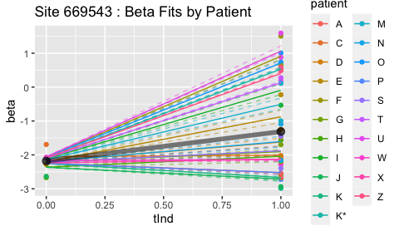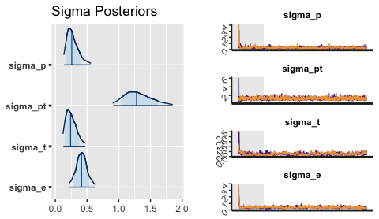  
Site 669543: Parameter posterior summary

|  |  |  |  |  |
| --- | --- | --- | --- | --- |
|  | mean | 50% | n_eff | Rhat |
| mu | -2.1805734 | -2.1825530 | 2032.4614 | 1.0008543 |
| betaT | 0.8698979 | 0.8941455 | 784.8199 | 1.0063431 |
| sigma_p | 0.2804204 | 0.2589059 | 474.5387 | 1.0027064 |
| sigma_pt | 1.3097359 | 1.2802224 | 2046.3660 | 0.9999552 |
| sigma_t | 0.2549310 | 0.2400696 | 182.2532 | 1.0362114 |
| sigma_e | 0.4140869 | 0.4134484 | 352.1623 | 1.0146480 |

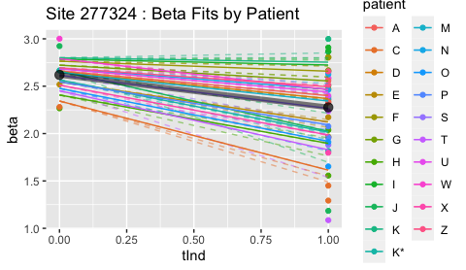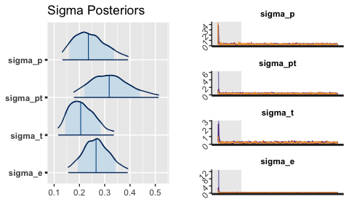  
Site 277324: Parameter posterior summary

|  |  |  |  |  |
| --- | --- | --- | --- | --- |
|  | mean | 50% | n_eff | Rhat |
| mu | 2.6187378 | 2.6127640 | 1442.2961 | 1.0001235 |
| betaT | -0.3420822 | -0.3382312 | 1395.2101 | 0.9996049 |
| sigma_p | 0.2433536 | 0.2354905 | 968.7159 | 1.0010759 |
| sigma_pt | 0.3241070 | 0.3178631 | 1137.6765 | 1.0007628 |
| sigma_t | 0.2104721 | 0.2050537 | 498.7452 | 1.0009681 |
| sigma_e | 0.2675370 | 0.2657007 | 657.6377 | 1.0073902 |

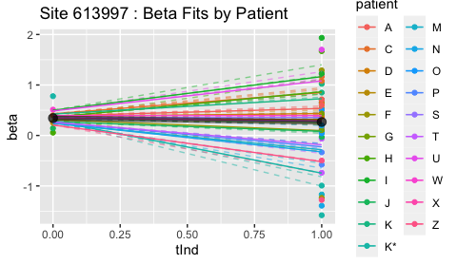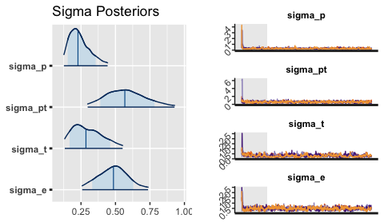  
Site 613997: Parameter posterior summary

|  |  |  |  |  |
| --- | --- | --- | --- | --- |
|  | mean | 50% | n_eff | Rhat |
| mu | 0.3439071 | 0.3438468 | 1563.0351 | 1.003380 |
| betaT | -0.0770534 | -0.0731092 | 1816.8131 | 1.002528 |
| sigma_p | 0.2435948 | 0.2279870 | 489.3659 | 1.007005 |
| sigma_pt | 0.5784405 | 0.5677318 | 889.1413 | 1.000898 |
| sigma_t | 0.3024778 | 0.2858204 | 203.3255 | 1.011087 |
| sigma_e | 0.4843462 | 0.4852784 | 321.2260 | 1.005116 |

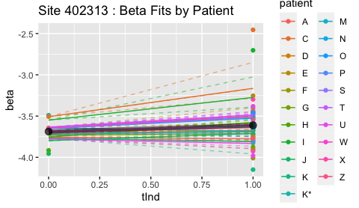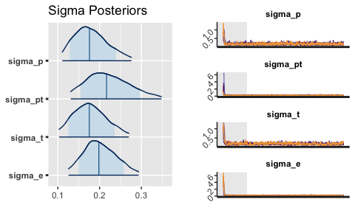  
Site 402313: Parameter posterior summary

|  |  |  |  |  |
| --- | --- | --- | --- | --- |
|  | mean | 50% | n_eff | Rhat |
| mu | -3.6869058 | -3.6877911 | 2514.7067 | 1.001031 |
| betaT | 0.0748287 | 0.0719267 | 2426.6824 | 1.000617 |
| sigma_p | 0.1808913 | 0.1757962 | 1308.9095 | 1.001180 |
| sigma_pt | 0.2226085 | 0.2166127 | 1326.9601 | 1.002010 |
| sigma_t | 0.1782833 | 0.1753382 | 636.1204 | 1.010023 |
| sigma_e | 0.2020177 | 0.1982747 | 911.7701 | 1.008764 |

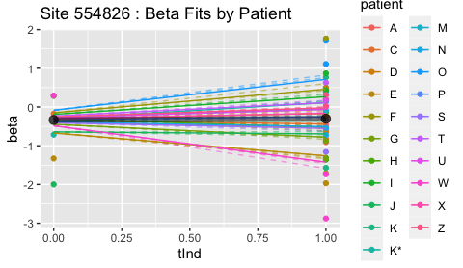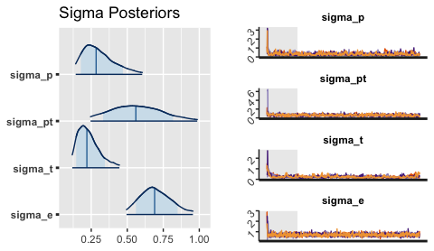  
Site 554826: Parameter posterior summary

|  |  |  |  |  |
| --- | --- | --- | --- | --- |
|  | mean | 50% | n_eff | Rhat |
| mu | -0.3345246 | -0.3286250 | 1781.7792 | 0.9996898 |
| betaT | 0.0328053 | 0.0167510 | 1821.8267 | 1.0004093 |
| sigma_p | 0.3073872 | 0.2836380 | 411.7405 | 1.0010744 |
| sigma_pt | 0.5709294 | 0.5595933 | 654.4805 | 1.0086262 |
| sigma_t | 0.2344464 | 0.2196620 | 211.9924 | 1.0074275 |
| sigma_e | 0.7000180 | 0.6898827 | 1142.9190 | 1.0020032 |

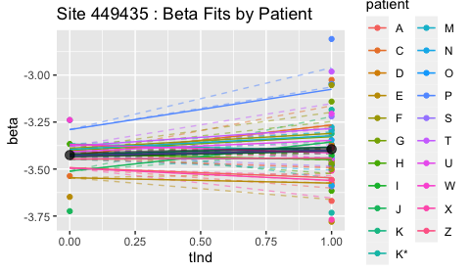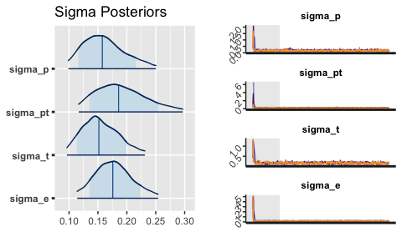  
Site 449435: Parameter posterior summary

|  |  |  |  |  |
| --- | --- | --- | --- | --- |
|  | mean | 50% | n_eff | Rhat |
| mu | -3.4253801 | -3.4247936 | 2533.4560 | 0.9992069 |
| betaT | 0.0313366 | 0.0304851 | 2444.6318 | 0.9994300 |
| sigma_p | 0.1620241 | 0.1575049 | 1082.5704 | 1.0036169 |
| sigma_pt | 0.1913304 | 0.1857819 | 1521.2655 | 1.0012218 |
| sigma_t | 0.1549608 | 0.1515807 | 716.6790 | 1.0030206 |
| sigma_e | 0.1777792 | 0.1757231 | 871.3138 | 1.0023554 |

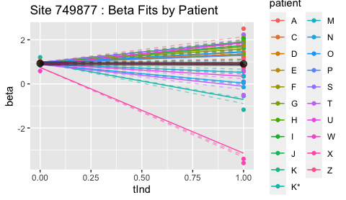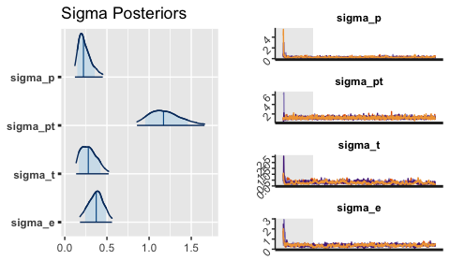  
Site 749877: Parameter posterior summary

|  |  |  |  |  |
| --- | --- | --- | --- | --- |
|  | mean | 50% | n_eff | Rhat |
| mu | 0.9312250 | 0.9294525 | 1978.2302 | 1.0001648 |
| betaT | -0.0232548 | -0.0250643 | 1762.6091 | 1.0004880 |
| sigma_p | 0.2400266 | 0.2218485 | 501.2755 | 1.0138955 |
| sigma_pt | 1.1933537 | 1.1711986 | 2448.4938 | 0.9994085 |
| sigma_t | 0.2892767 | 0.2793102 | 159.5280 | 1.0334410 |
| sigma_e | 0.3700924 | 0.3728920 | 191.4515 | 1.0169385 |

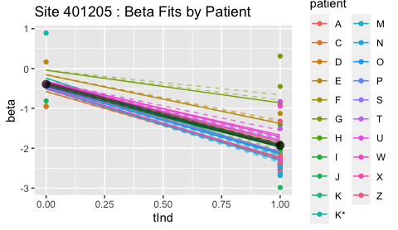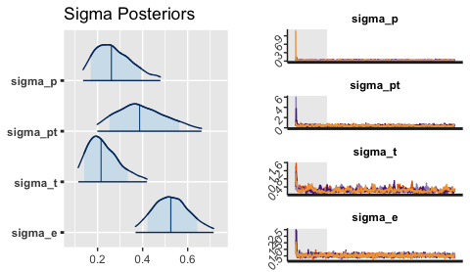  
Site 401205: Parameter posterior summary

|  |  |  |  |  |
| --- | --- | --- | --- | --- |
|  | mean | 50% | n_eff | Rhat |
| mu | -0.3925223 | -0.3824372 | 2247.2532 | 1.000899 |
| betaT | -1.5359901 | -1.5339377 | 2207.0279 | 1.001134 |
| sigma_p | 0.2739425 | 0.2612517 | 637.8674 | 1.002773 |
| sigma_pt | 0.3998907 | 0.3864637 | 842.1119 | 1.003407 |
| sigma_t | 0.2291110 | 0.2155689 | 267.9226 | 1.015707 |
| sigma_e | 0.5290701 | 0.5251146 | 1140.1244 | 1.001635 |

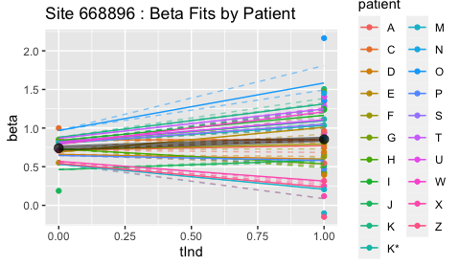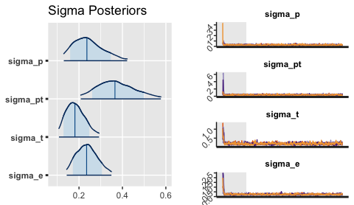  
Site 668896: Parameter posterior summary

|  |  |  |  |  |
| --- | --- | --- | --- | --- |
|  | mean | 50% | n_eff | Rhat |
| mu | 0.7400618 | 0.7381931 | 2387.2536 | 0.999823 |
| betaT | 0.1148868 | 0.1094715 | 2446.8470 | 1.000776 |
| sigma_p | 0.2460412 | 0.2363610 | 872.1218 | 1.004658 |
| sigma_pt | 0.3731079 | 0.3657137 | 1404.9324 | 1.000842 |
| sigma_t | 0.1860052 | 0.1812124 | 509.1637 | 1.010534 |
| sigma_e | 0.2375062 | 0.2350793 | 699.8343 | 1.006020 |

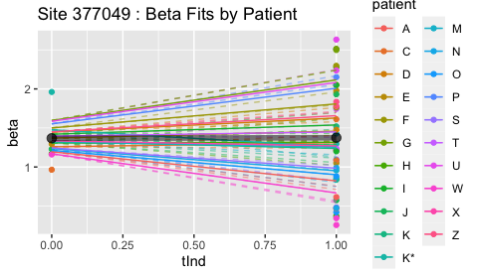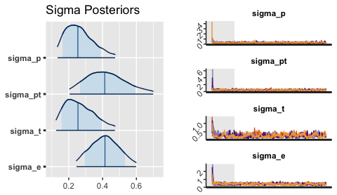  
Site 377049: Parameter posterior summary

|  |  |  |  |  |
| --- | --- | --- | --- | --- |
|  | mean | 50% | n_eff | Rhat |
| mu | 1.3681009 | 1.3695612 | 2078.7413 | 1.001759 |
| betaT | 0.0070631 | 0.0002960 | 2598.7081 | 1.001773 |
| sigma_p | 0.2668456 | 0.2538523 | 467.5916 | 1.002775 |
| sigma_pt | 0.4240139 | 0.4128265 | 764.8475 | 1.000415 |
| sigma_t | 0.2670954 | 0.2543873 | 223.2246 | 1.016559 |
| sigma_e | 0.4145233 | 0.4141928 | 418.6310 | 1.012782 |

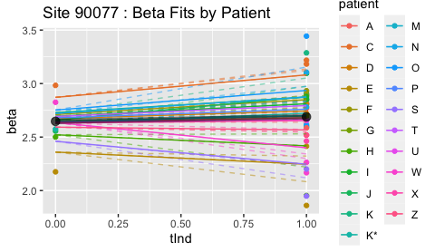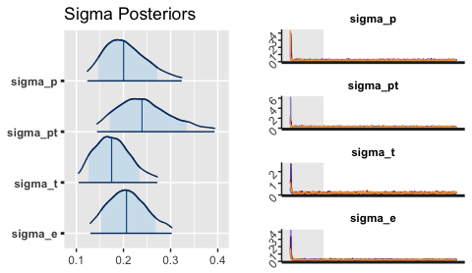  
Site 90077: Parameter posterior summary

|  |  |  |  |  |
| --- | --- | --- | --- | --- |
|  | mean | 50% | n_eff | Rhat |
| mu | 2.6468943 | 2.6489136 | 2085.1897 | 1.000554 |
| betaT | 0.0419663 | 0.0358408 | 2098.7379 | 1.001544 |
| sigma_p | 0.2056931 | 0.2001938 | 1314.8777 | 1.002672 |
| sigma_pt | 0.2464099 | 0.2393219 | 1620.5887 | 1.000476 |
| sigma_t | 0.1779885 | 0.1748909 | 485.4683 | 1.007817 |
| sigma_e | 0.2087849 | 0.2063801 | 818.7627 | 1.004652 |

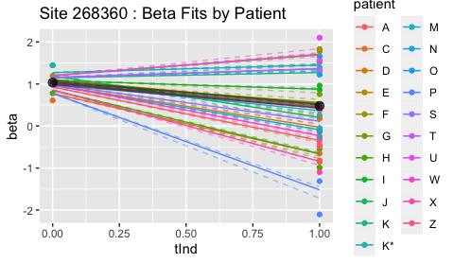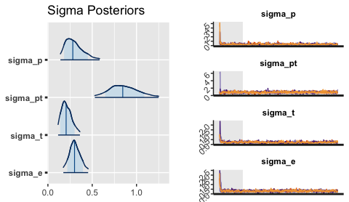  
Site 268360: Parameter posterior summary

|  |  |  |  |  |
| --- | --- | --- | --- | --- |
|  | mean | 50% | n_eff | Rhat |
| mu | 1.0346083 | 1.0334526 | 1624.2098 | 1.001169 |
| betaT | -0.5544482 | -0.5531254 | 763.1199 | 1.001747 |
| sigma_p | 0.3018777 | 0.2810143 | 423.8647 | 1.016336 |
| sigma_pt | 0.8582428 | 0.8447045 | 1056.7213 | 1.004696 |
| sigma_t | 0.2143644 | 0.2055793 | 259.1792 | 1.004881 |
| sigma_e | 0.3053431 | 0.3005688 | 554.4133 | 1.004341 |

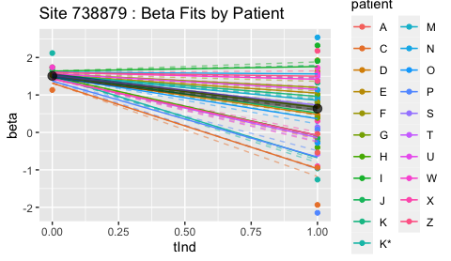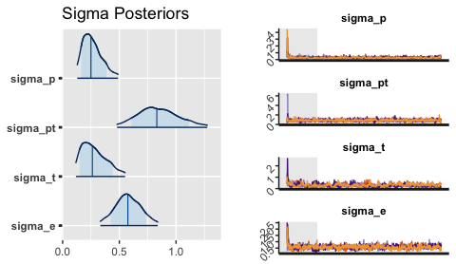  
Site 738879: Parameter posterior summary

|  |  |  |  |  |
| --- | --- | --- | --- | --- |
|  | mean | 50% | n_eff | Rhat |
| mu | 1.5085730 | 1.5207452 | 1388.9363 | 1.003955 |
| betaT | -0.8724712 | -0.8941109 | 964.4589 | 1.005664 |
| sigma_p | 0.2660154 | 0.2495369 | 563.0363 | 1.008525 |
| sigma_pt | 0.8475088 | 0.8305731 | 986.7249 | 1.001719 |
| sigma_t | 0.2830059 | 0.2623727 | 137.5331 | 1.036037 |
| sigma_e | 0.5793507 | 0.5750488 | 308.7775 | 1.023028 |

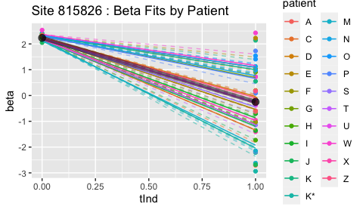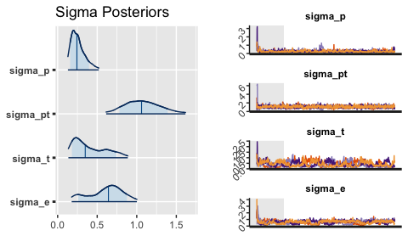  
Site 815826: Parameter posterior summary

|  |  |  |  |  |
| --- | --- | --- | --- | --- |
|  | mean | 50% | n_eff | Rhat |
| mu | 2.2343007 | 2.2549941 | 1226.06413 | 1.001500 |
| betaT | -2.4815245 | -2.4934308 | 1100.85042 | 1.000663 |
| sigma_p | 0.2645901 | 0.2435065 | 229.80854 | 1.018048 |
| sigma_pt | 1.0759683 | 1.0606089 | 1061.91763 | 1.002885 |
| sigma_t | 0.4148161 | 0.3488007 | 66.97566 | 1.043199 |
| sigma_e | 0.6094886 | 0.6422428 | 81.23907 | 1.028487 |

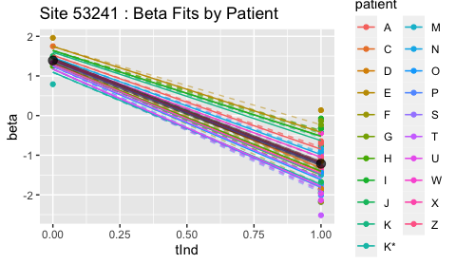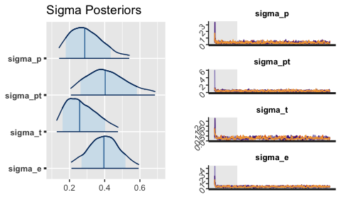  
Site 53241: Parameter posterior summary

|  |  |  |  |  |
| --- | --- | --- | --- | --- |
|  | mean | 50% | n_eff | Rhat |
| mu | 1.3910332 | 1.3966509 | 2359.4872 | 1.000049 |
| betaT | -2.6057283 | -2.6068153 | 2155.3563 | 1.000571 |
| sigma_p | 0.2994640 | 0.2869215 | 512.5978 | 1.004849 |
| sigma_pt | 0.4153122 | 0.4027100 | 757.2249 | 1.002057 |
| sigma_t | 0.2715455 | 0.2577336 | 241.7878 | 1.013095 |
| sigma_e | 0.3957064 | 0.3954423 | 348.8845 | 1.019069 |

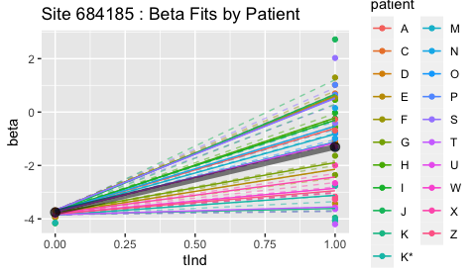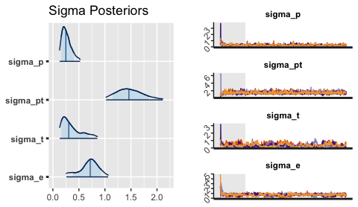  
Site 684185: Parameter posterior summary

|  |  |  |  |  |
| --- | --- | --- | --- | --- |
|  | mean | 50% | n_eff | Rhat |
| mu | -3.7549098 | -3.7770920 | 1411.16176 | 1.002573 |
| betaT | 2.4486284 | 2.4636798 | 942.42906 | 1.007680 |
| sigma_p | 0.2699767 | 0.2489980 | 444.22672 | 1.019240 |
| sigma_pt | 1.4854284 | 1.4607807 | 1504.78652 | 1.001351 |
| sigma_t | 0.3683958 | 0.3050975 | 62.82204 | 1.065490 |
| sigma_e | 0.6940544 | 0.7178058 | 85.37148 | 1.044680 |

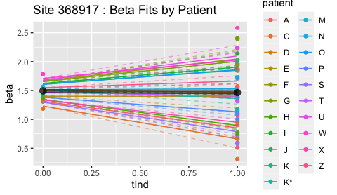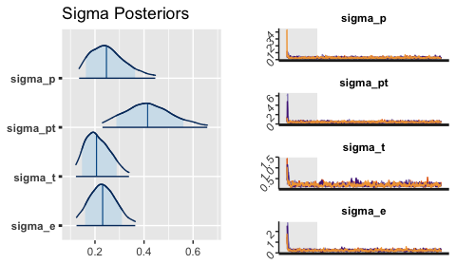  
Site 368917: Parameter posterior summary

|  |  |  |  |  |
| --- | --- | --- | --- | --- |
|  | mean | 50% | n_eff | Rhat |
| mu | 1.4934950 | 1.4901650 | 1826.8681 | 1.0009338 |
| betaT | -0.0302125 | -0.0293008 | 2262.3017 | 0.9993157 |
| sigma_p | 0.2572196 | 0.2467594 | 619.0573 | 1.0053201 |
| sigma_pt | 0.4206503 | 0.4146441 | 838.8288 | 1.0046819 |
| sigma_t | 0.2136771 | 0.2062515 | 419.4566 | 1.0110908 |
| sigma_e | 0.2338123 | 0.2313118 | 473.8588 | 1.0066225 |

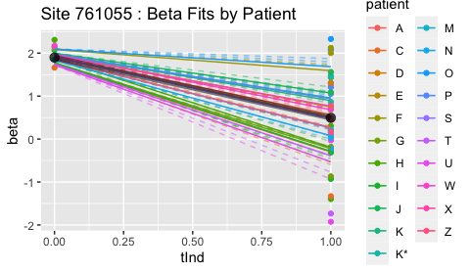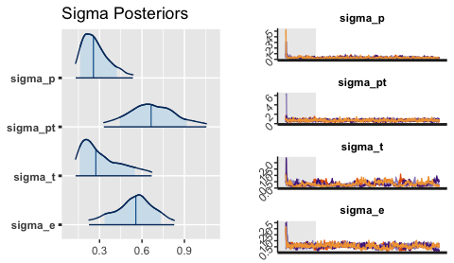  
Site 761055: Parameter posterior summary

|  |  |  |  |  |
| --- | --- | --- | --- | --- |
|  | mean | 50% | n_eff | Rhat |
| mu | 1.8971944 | 1.9223709 | 1473.8572 | 1.001634 |
| betaT | -1.4027780 | -1.4249624 | 1372.2622 | 1.002195 |
| sigma_p | 0.2769416 | 0.2565009 | 394.0882 | 1.006503 |
| sigma_pt | 0.6739110 | 0.6644944 | 828.3003 | 1.003245 |
| sigma_t | 0.3185756 | 0.2734133 | 105.0226 | 1.031626 |
| sigma_e | 0.5452363 | 0.5563900 | 144.3114 | 1.022990 |

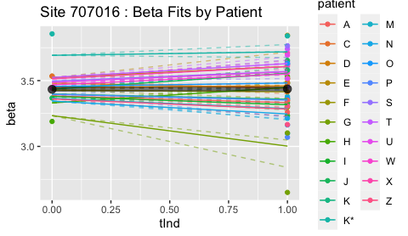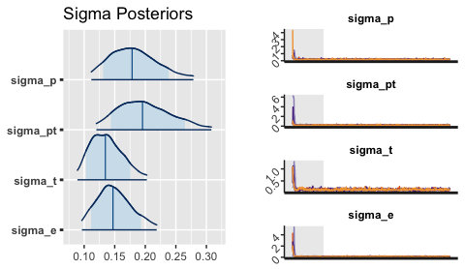  
Site 707016: Parameter posterior summary

|  |  |  |  |  |
| --- | --- | --- | --- | --- |
|  | mean | 50% | n_eff | Rhat |
| mu | 3.4340072 | 3.4353660 | 1881.0782 | 0.9999354 |
| betaT | 0.0027604 | -0.0003046 | 2343.9820 | 0.9996108 |
| sigma_p | 0.1826149 | 0.1784228 | 1190.8945 | 1.0019461 |
| sigma_pt | 0.2004101 | 0.1954463 | 1712.8021 | 1.0000132 |
| sigma_t | 0.1372088 | 0.1346242 | 644.7046 | 1.0055567 |
| sigma_e | 0.1500070 | 0.1470719 | 808.1592 | 1.0023455 |

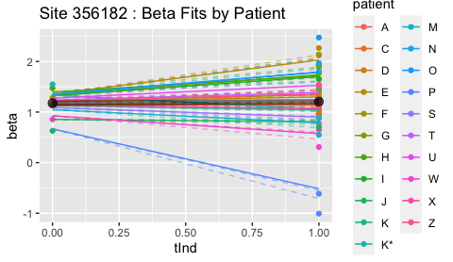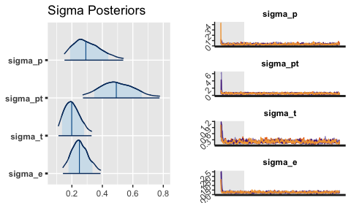  
Site 356182: Parameter posterior summary

|  |  |  |  |  |
| --- | --- | --- | --- | --- |
|  | mean | 50% | n_eff | Rhat |
| mu | 1.1756224 | 1.1761245 | 1720.5289 | 1.001631 |
| betaT | 0.0297608 | 0.0215877 | 2142.6729 | 1.001507 |
| sigma_p | 0.3056310 | 0.2914688 | 623.5064 | 1.004879 |
| sigma_pt | 0.5002654 | 0.4913984 | 1142.6560 | 1.003947 |
| sigma_t | 0.2041759 | 0.1990017 | 398.3813 | 1.014554 |
| sigma_e | 0.2529438 | 0.2493560 | 495.9831 | 1.008447 |

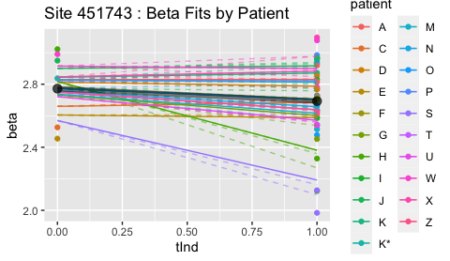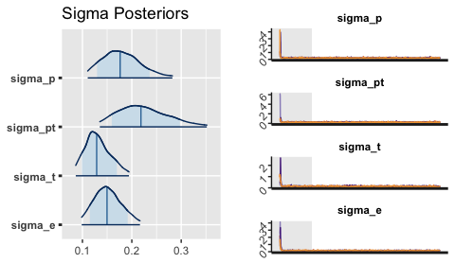  
Site 451743: Parameter posterior summary

|  |  |  |  |  |
| --- | --- | --- | --- | --- |
|  | mean | 50% | n_eff | Rhat |
| mu | 2.7719558 | 2.7718095 | 1544.6496 | 1.003580 |
| betaT | -0.0791364 | -0.0781180 | 1923.9169 | 1.003162 |
| sigma_p | 0.1806760 | 0.1764724 | 1732.3049 | 1.000063 |
| sigma_pt | 0.2249703 | 0.2185545 | 1639.0752 | 1.001138 |
| sigma_t | 0.1322777 | 0.1287973 | 485.5665 | 1.005262 |
| sigma_e | 0.1520585 | 0.1498219 | 1073.7346 | 1.001424 |

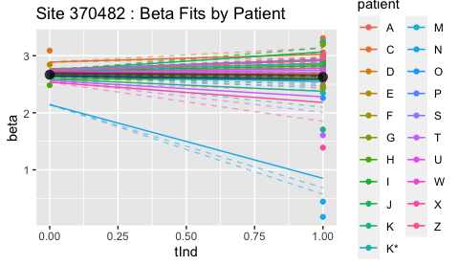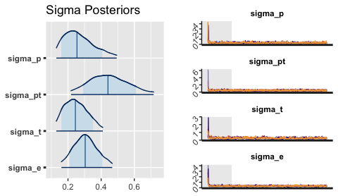  
Site 370482: Parameter posterior summary

|  |  |  |  |  |
| --- | --- | --- | --- | --- |
|  | mean | 50% | n_eff | Rhat |
| mu | 2.6667889 | 2.6697370 | 1852.9234 | 1.002098 |
| betaT | -0.0403534 | -0.0380449 | 2427.5071 | 1.002336 |
| sigma_p | 0.2708926 | 0.2541555 | 456.7449 | 1.016488 |
| sigma_pt | 0.4470817 | 0.4409591 | 890.7707 | 1.009280 |
| sigma_t | 0.2510083 | 0.2445285 | 302.7102 | 1.020008 |
| sigma_e | 0.3063785 | 0.3038743 | 331.8107 | 1.018567 |

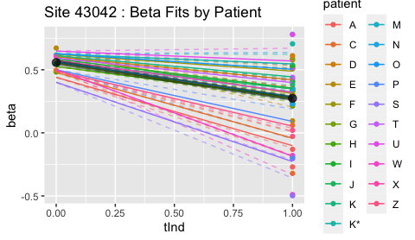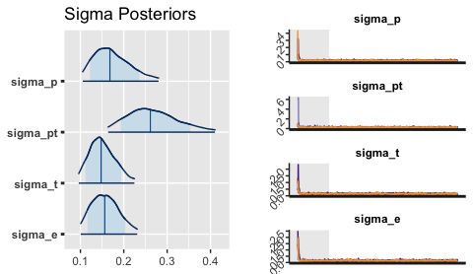  
Site 43042: Parameter posterior summary

|  |  |  |  |  |
| --- | --- | --- | --- | --- |
|  | mean | 50% | n_eff | Rhat |
| mu | 0.5573505 | 0.5569830 | 2019.2824 | 1.000791 |
| betaT | -0.2833228 | -0.2841308 | 1903.4211 | 1.001715 |
| sigma_p | 0.1747818 | 0.1680529 | 1252.5826 | 1.000413 |
| sigma_pt | 0.2686928 | 0.2612839 | 1858.2826 | 1.000784 |
| sigma_t | 0.1512632 | 0.1477384 | 629.2612 | 1.003056 |
| sigma_e | 0.1581938 | 0.1561680 | 753.6031 | 1.003270 |

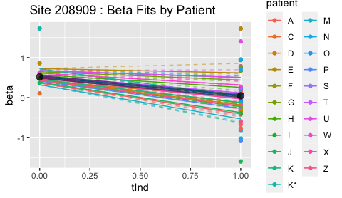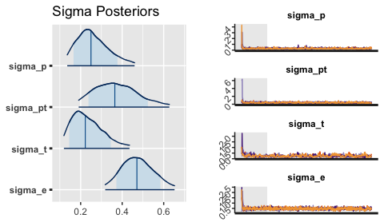  
Site 208909: Parameter posterior summary

|  |  |  |  |  |
| --- | --- | --- | --- | --- |
|  | mean | 50% | n_eff | Rhat |
| mu | 0.5177768 | 0.5143318 | 1837.7476 | 1.000476 |
| betaT | -0.4713206 | -0.4613598 | 1790.8170 | 1.001044 |
| sigma_p | 0.2627978 | 0.2497895 | 634.2153 | 1.003668 |
| sigma_pt | 0.3747403 | 0.3645868 | 900.2522 | 1.007329 |
| sigma_t | 0.2363389 | 0.2224714 | 235.8724 | 1.011154 |
| sigma_e | 0.4748798 | 0.4708307 | 920.2178 | 1.002728 |

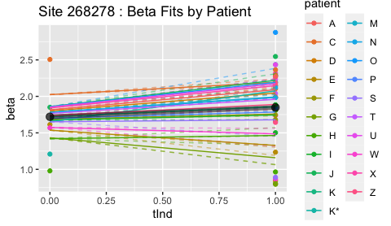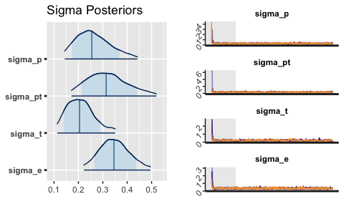  
Site 268278: Parameter posterior summary

|  |  |  |  |  |
| --- | --- | --- | --- | --- |
|  | mean | 50% | n_eff | Rhat |
| mu | 1.7206306 | 1.7201133 | 2131.5652 | 0.9997183 |
| betaT | 0.1275807 | 0.1130436 | 2161.3662 | 0.9993765 |
| sigma_p | 0.2646384 | 0.2547337 | 910.2391 | 1.0066032 |
| sigma_pt | 0.3212980 | 0.3136737 | 1037.2811 | 1.0016802 |
| sigma_t | 0.2104373 | 0.2045945 | 360.5842 | 1.0018451 |
| sigma_e | 0.3490087 | 0.3456425 | 992.3657 | 1.0020372 |

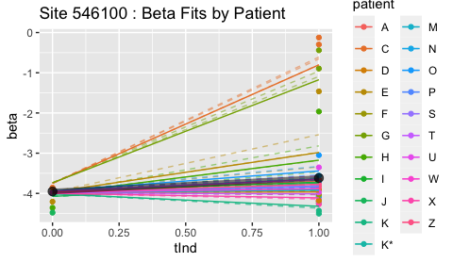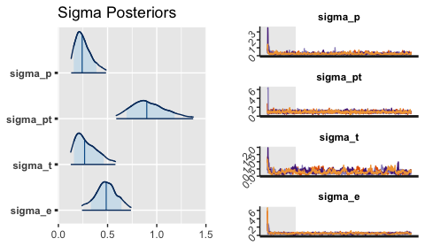  
Site 546100: Parameter posterior summary

|  |  |  |  |  |
| --- | --- | --- | --- | --- |
|  | mean | 50% | n_eff | Rhat |
| mu | -3.9509894 | -3.9566526 | 1269.0939 | 1.000997 |
| betaT | 0.3340738 | 0.3059116 | 1105.6106 | 1.000783 |
| sigma_p | 0.2591964 | 0.2413689 | 456.1638 | 1.011443 |
| sigma_pt | 0.9225805 | 0.8985287 | 1585.8323 | 1.000639 |
| sigma_t | 0.2926993 | 0.2663217 | 159.3168 | 1.019526 |
| sigma_e | 0.4873115 | 0.4861345 | 233.2181 | 1.013926 |

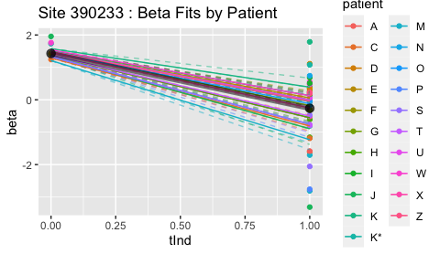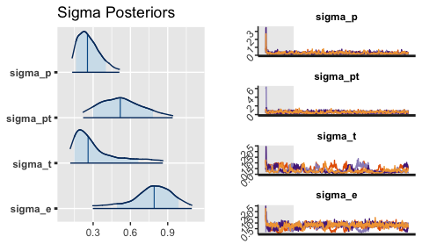  
Site 390233: Parameter posterior summary

|  |  |  |  |  |
| --- | --- | --- | --- | --- |
|  | mean | 50% | n_eff | Rhat |
| mu | 1.4298224 | 1.4618767 | 799.47792 | 1.006672 |
| betaT | -1.6933469 | -1.7246216 | 824.89419 | 1.003426 |
| sigma_p | 0.2712146 | 0.2542601 | 487.82921 | 1.009726 |
| sigma_pt | 0.5334789 | 0.5183031 | 512.31336 | 1.010038 |
| sigma_t | 0.3317755 | 0.2595559 | 78.54747 | 1.048524 |
| sigma_e | 0.7691347 | 0.7910545 | 124.72126 | 1.029627 |

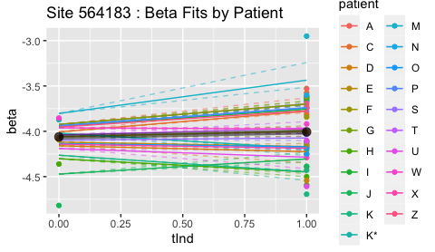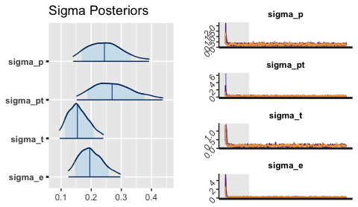  
Site 564183: Parameter posterior summary

|  |  |  |  |  |
| --- | --- | --- | --- | --- |
|  | mean | 50% | n_eff | Rhat |
| mu | -4.0615837 | -4.0656843 | 1903.6370 | 0.9998431 |
| betaT | 0.0548031 | 0.0495200 | 2197.1154 | 1.0005596 |
| sigma_p | 0.2486192 | 0.2438535 | 1125.1464 | 1.0027828 |
| sigma_pt | 0.2758471 | 0.2694004 | 1187.5543 | 0.9996913 |
| sigma_t | 0.1581270 | 0.1541286 | 420.7298 | 1.0079539 |
| sigma_e | 0.1997078 | 0.1954203 | 722.7728 | 1.0041946 |

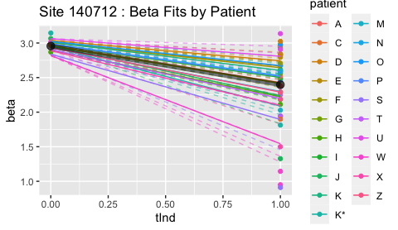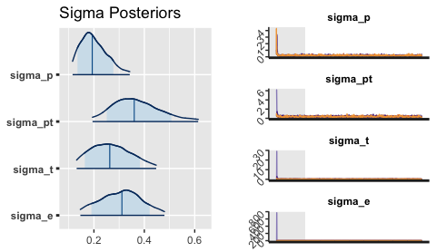  
Site 140712: Parameter posterior summary

|  |  |  |  |  |
| --- | --- | --- | --- | --- |
|  | mean | 50% | n_eff | Rhat |
| mu | 2.9564597 | 2.9629712 | 1740.0129 | 1.003318 |
| betaT | -0.5588656 | -0.5686542 | 1818.2808 | 1.000247 |
| sigma_p | 0.2018593 | 0.1932519 | 726.6998 | 1.001212 |
| sigma_pt | 0.3710661 | 0.3599073 | 992.4399 | 1.004270 |
| sigma_t | 0.2700313 | 0.2627355 | 318.5983 | 1.012872 |
| sigma_e | 0.3083649 | 0.3111877 | 305.0469 | 1.012381 |

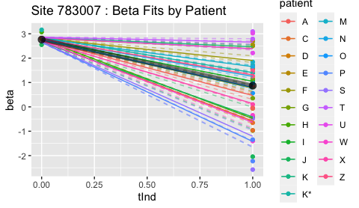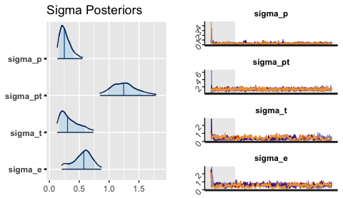  
Site 783007: Parameter posterior summary

|  |  |  |  |  |
| --- | --- | --- | --- | --- |
|  | mean | 50% | n_eff | Rhat |
| mu | 2.7640843 | 2.7813968 | 1595.60395 | 1.003033 |
| betaT | -1.8939812 | -1.9085636 | 836.31279 | 1.003724 |
| sigma_p | 0.2725521 | 0.2501918 | 416.36435 | 1.004446 |
| sigma_pt | 1.2600401 | 1.2434003 | 2378.53198 | 1.001512 |
| sigma_t | 0.3469233 | 0.3040752 | 74.43585 | 1.074147 |
| sigma_e | 0.5560462 | 0.5761680 | 96.74578 | 1.058812 |

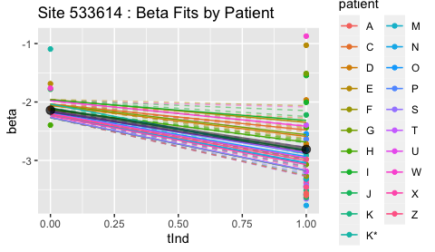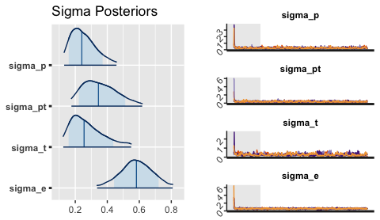  
Site 533614: Parameter posterior summary

|  |  |  |  |  |
| --- | --- | --- | --- | --- |
|  | mean | 50% | n_eff | Rhat |
| mu | -2.1395137 | -2.1362623 | 1285.4619 | 1.001906 |
| betaT | -0.6713672 | -0.6781510 | 1499.9495 | 1.002352 |
| sigma_p | 0.2558628 | 0.2406092 | 525.9105 | 1.000760 |
| sigma_pt | 0.3585588 | 0.3444253 | 543.2406 | 1.008661 |
| sigma_t | 0.2783010 | 0.2551036 | 159.1359 | 1.009965 |
| sigma_e | 0.5817633 | 0.5820446 | 332.8135 | 1.006627 |

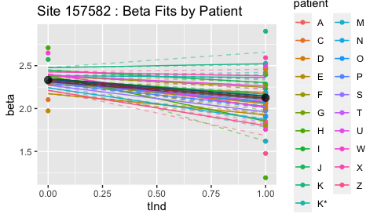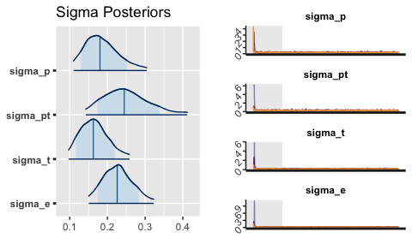  
Site 157582: Parameter posterior summary

|  |  |  |  |  |
| --- | --- | --- | --- | --- |
|  | mean | 50% | n_eff | Rhat |
| mu | 2.3327482 | 2.3349883 | 1831.8340 | 1.004836 |
| betaT | -0.2071529 | -0.2039878 | 1713.0151 | 1.001815 |
| sigma_p | 0.1871498 | 0.1802959 | 1308.7422 | 1.003456 |
| sigma_pt | 0.2520485 | 0.2446800 | 1037.2023 | 1.000772 |
| sigma_t | 0.1661487 | 0.1626155 | 439.7399 | 1.009211 |
| sigma_e | 0.2279389 | 0.2259652 | 949.6784 | 1.005117 |

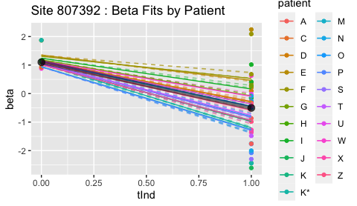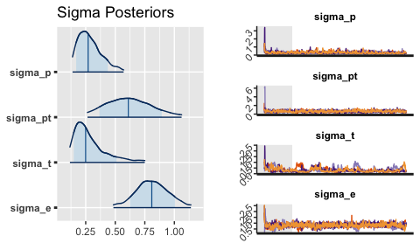  
Site 807392: Parameter posterior summary

|  |  |  |  |  |
| --- | --- | --- | --- | --- |
|  | mean | 50% | n_eff | Rhat |
| mu | 1.1015957 | 1.1233642 | 1602.4518 | 1.002288 |
| betaT | -1.6037448 | -1.6193797 | 1356.7590 | 1.003854 |
| sigma_p | 0.2919152 | 0.2706340 | 347.3838 | 1.029536 |
| sigma_pt | 0.6221579 | 0.6105936 | 318.7382 | 1.010584 |
| sigma_t | 0.2945947 | 0.2495351 | 97.8909 | 1.038194 |
| sigma_e | 0.8108480 | 0.8091033 | 272.1618 | 1.016571 |

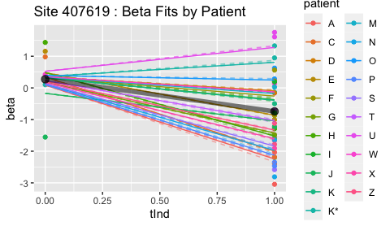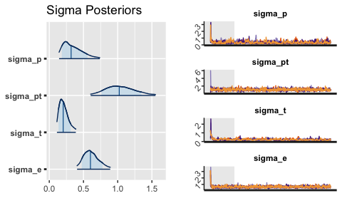  
Site 407619: Parameter posterior summary

|  |  |  |  |  |
| --- | --- | --- | --- | --- |
|  | mean | 50% | n_eff | Rhat |
| mu | 0.2743095 | 0.2858397 | 1910.1892 | 1.0003061 |
| betaT | -1.0169732 | -1.0413553 | 968.8600 | 1.0027660 |
| sigma_p | 0.3521524 | 0.3190134 | 296.6789 | 1.0125849 |
| sigma_pt | 1.0405797 | 1.0229083 | 1440.1301 | 0.9998301 |
| sigma_t | 0.2155106 | 0.2034672 | 255.3375 | 1.0264514 |
| sigma_e | 0.6159827 | 0.6017720 | 729.9276 | 1.0025836 |

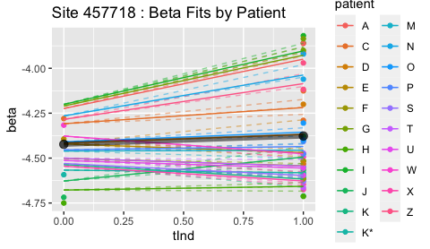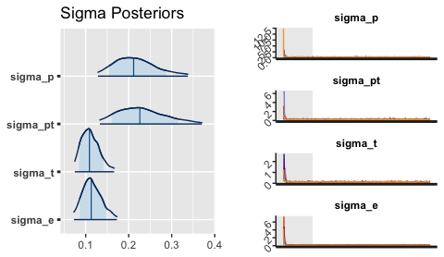  
Site 457718: Parameter posterior summary

|  |  |  |  |  |
| --- | --- | --- | --- | --- |
|  | mean | 50% | n_eff | Rhat |
| mu | -4.4230937 | -4.4230665 | 1438.8341 | 1.000481 |
| betaT | 0.0461039 | 0.0455312 | 1542.6608 | 1.001084 |
| sigma_p | 0.2174147 | 0.2114516 | 1221.6175 | 1.003676 |
| sigma_pt | 0.2320433 | 0.2258934 | 1174.7560 | 1.001351 |
| sigma_t | 0.1114893 | 0.1087868 | 639.0555 | 1.004587 |
| sigma_e | 0.1154763 | 0.1128800 | 572.3833 | 1.005189 |

## user system elapsed   
## 657.184 16.162 685.498

## [1] "Completed run on sites: 188942 134058 124022 685285 226318 365209 648795 193627 569692 589449 832867 497690 402858 583422 183204 669543 277324 613997 402313 554826 449435 749877 401205 668896 377049 90077 268360 738879 815826 53241 684185 368917 761055 707016 356182 451743 370482 43042 208909 268278 546100 390233 564183 140712 783007 533614 157582 807392 407619 457718"

## [1] "n_eff averages: 1718 1589 699 1195 313 546"